**Practical No:-** 1

**Roll No.:**15 **Batch-** A **Date of Performance:** 06/01/2024

1. **Write a program to print “Welcome to PHP”**

<?php

echo"<b> Welcome to PHP</b>";

?>

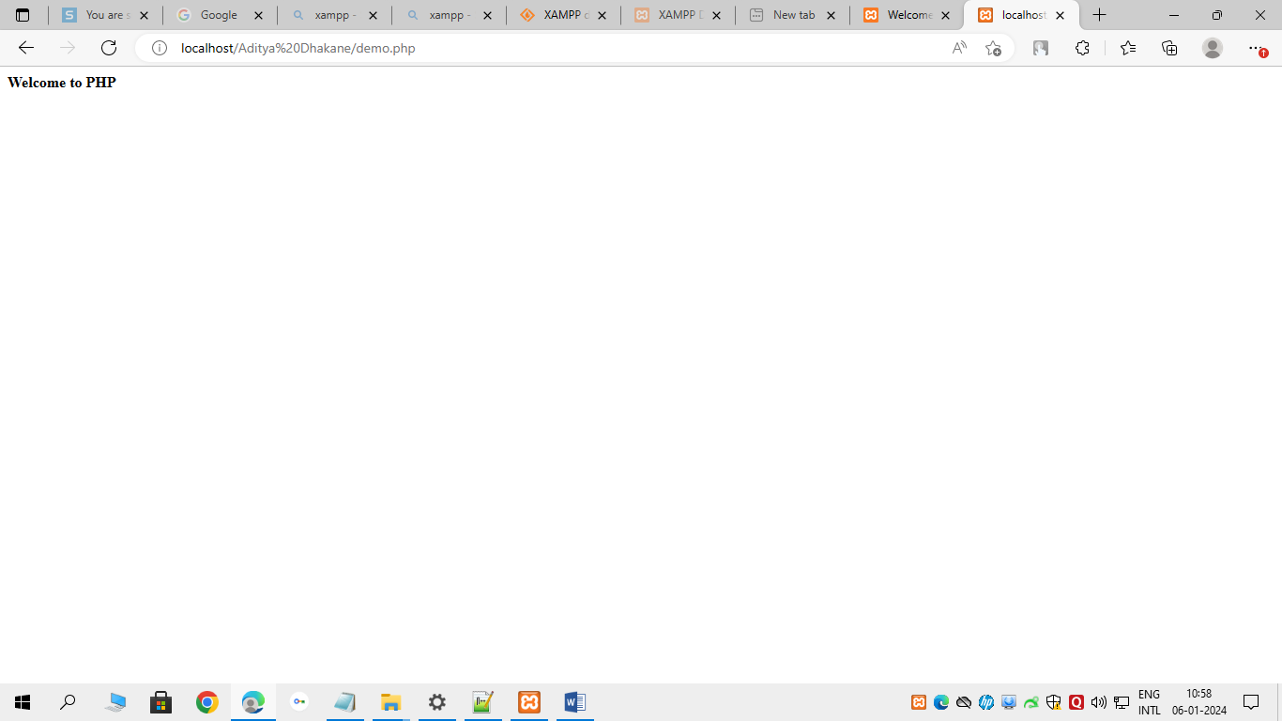

1. **Write a simple PHP program using expressions and Operators.**

<?php

$a=10;

$b=20;

echo "a=".($a)." b=".($b);

echo "<br>a=".(getType($a)."<br>b=".getType($b));

echo "<br><br>Arithmetic Operations";

echo "<br>Addition=".($a+$b);

echo "<br>Subtraction=".($a-$b);

echo "<br>Multiplication=".($a*$b);

echo "<br>Division=".($a/$b);

?>

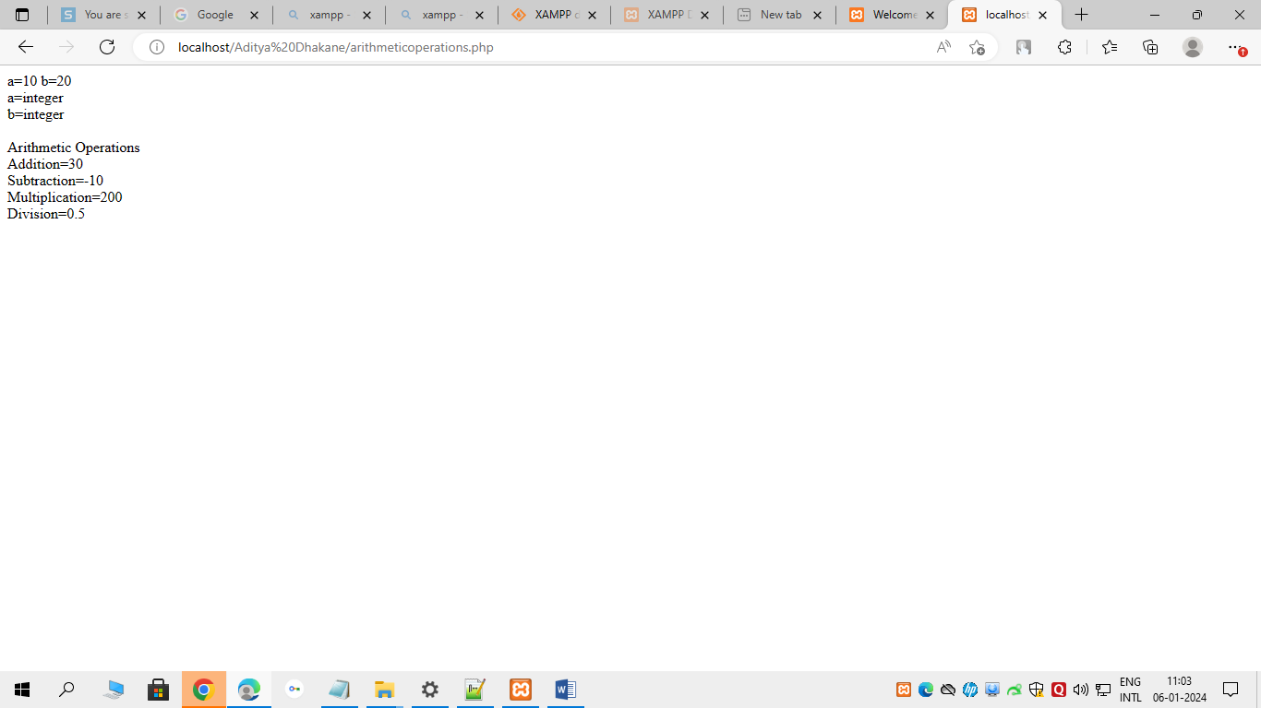

1. **Write a PHP program swap 2 numbers**

<?php

$a=10;

$b=20;

$temp;

echo "Before Swapping:";

echo "a=".$a . " b=".$b;

$temp=$a;

$a=$b;

$b=$temp;

echo "<br>After Swapping:";

echo "a=".$a . " b=".$b;

?>

